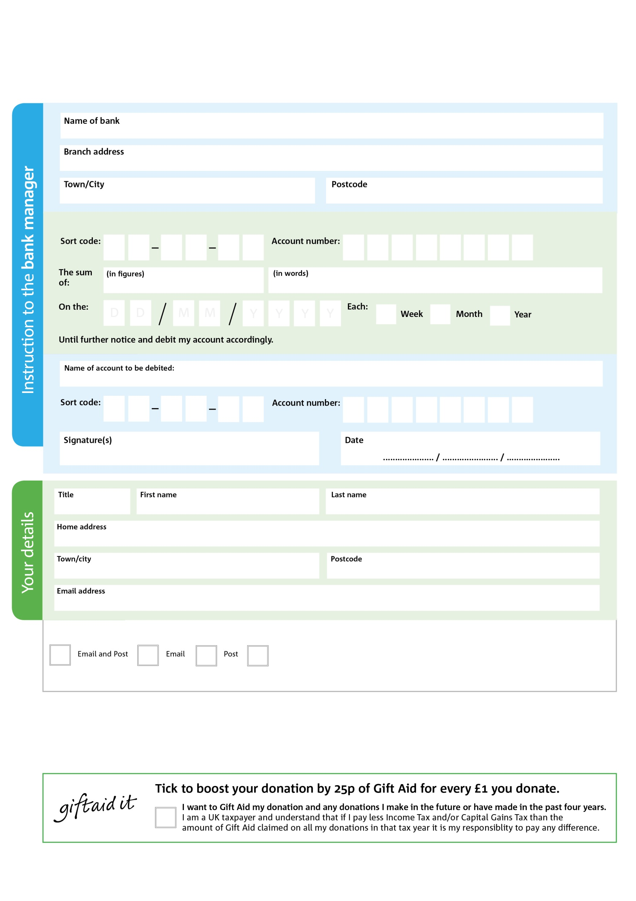

**Please pass this form onto the foodbank, using the address below, who will save a copy for their records and will send it to your named bank or building society.**

You can change your preferences any time by contacting us on 07922808086 or emailing us at info@plympton.foodbank.org.uk

**Data protection**

Plympton Foodbank is committed to protecting your privacy and will process your personal data in accordance with the Data Protection Act 1998. XXXXX Foodbank collects information to keep in touch with you and supply you with information relating to our work. XXXXX Foodbank will never sell or pass your details to anyone who isn’t directly working on our behalf.

Reg. Charity No: 1128769 | Parochial Church Council of Ecclesiastical Parish of Plympton St Mary the Blessed Virgin; Reg. in England & Wales

POSTAL ADDRESS: Plympton Foodbank, c/o PCC Plympton St Mary Parish, 10 Market Road Road, Plympton, Plymouth, PL7 1QW

We would love to keep you up to date with information about Plympton Foodbank. Please tick your preference:

Please pay Plympton Foodbank,

**Standing Order Mandate**

**plympton.foodbank.org.uk**

I do not wish to receive future communications from Plympton Foodbank