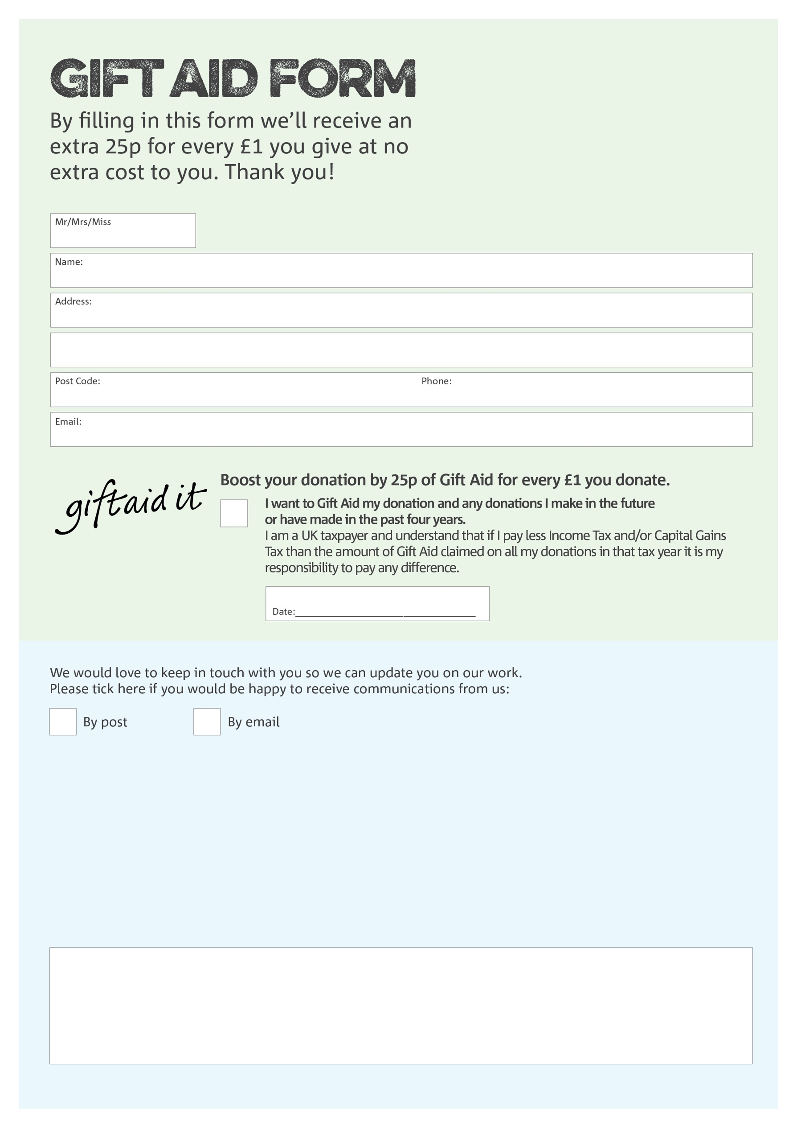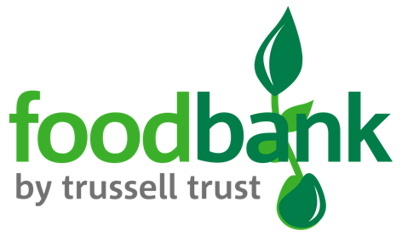

Plympton Foodbank works under The Parochial Church Council Parish Church of Plympton St Mary. Charity Number 1128769. Registered in England & Wales- see Charity Commission website for information.

We would love to know why you have chosen to donate to Plympton Foodbank. If you would like to share your motivation let us know below:

**Data protection**

Plympton Foodbank is committed to protecting your privacy and will process your personal data in accordance with the Data Protection Act 1998. Plympton Foodbank collects information to keep in touch with you and supply you with information relating to our work. Plympton Foodbank will never sell or pass your details to anyone who isn’t directly working on our behalf.

You can change your preferences any time by contacting us on 07922808086 or emailing us at

info@plympton.foodbank.org.uk